Project Design Phase-I
Solution Architecture

Date | 26 June 2026 | Team ID | N/A (Solo Project)
Project Name | Network Anomaly Detection | Maximum Marks | 4 Marks

Solution Architecture:

Solution Architecture Diagram — Network Anomaly Detection Data Flow
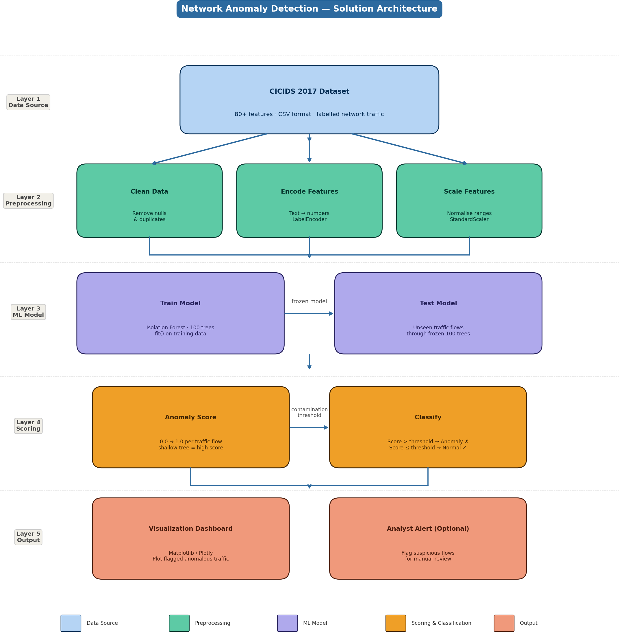

Figure 1: Architecture and data flow of the Network Anomaly Detection system using Isolation Forest on the CICIDS 2017 dataset

Key Architectural Decisions & Specifications

Component | Technology / Choice | Specification / Reason
Dataset | CICIDS 2017 (CSV) | Industry-standard benchmark; 80+ features; contains normal and attack traffic
Data Cleaning | Pandas | Remove null values, duplicate rows, and irrelevant columns
Feature Encoding | LabelEncoder (sklearn) | Convert categorical text columns (e.g. protocol type) to numeric values
Feature Scaling | StandardScaler (sklearn) | Normalise all features to equal ranges; prevents dominance by high-range feat
Detection Algorithm | Isolation Forest (sklearn) | Unsupervised; no labelled attack data needed; fast; interpretable anomaly scor
No. of Trees | n_estimators = 100 | Standard default; balances accuracy and computational speed
Anomaly Threshold | contamination = 0.05 | Assumes ~5% of traffic is anomalous; tunable based on dataset analysis
Visualization | Matplotlib / Plotly | Lightweight plotting; no server infrastructure needed for academic MVP
Development Phase | Single-phase MVP | Solo project; all components built and tested in one development cycle

Project: Network Anomaly Detection | Phase: Project Design Phase-I | Solo Developer

ures es

